**P a g e | 1\**

### A MAJOR PROJECT REPORT

**ON**

**Cricket Uncovered**

#### By

**Aum Vashi (2203396160383)**

**Preet Desai (2203396160060)**

**Kirtan Chauhan (2203396160046)**

**Harikrushna Chauhan (2203396160047)**

**(5th sem Computer Engineering Department)**

##### INTERNAL GUIDE

**Prof. Tirthesh Gajjar**

**&**

**Prof. Raviraj Pandya**

(Computer Engineering Department)





**PARUL INSTITUTE OF ENGINEERING & TECHNOLOGY (DIPLOMA STUDIES)**

**P.O.LIMDA .TAL. WAGHODIA-391760**

# CERTIFICATE

This is to certify that Major Project by Aum Vashi(2203396160383), Preet Desai (2203396160060), Kirtan Chauhan(2203396160046), and Harikrushna Chauhan (2203396160047) of Computer Department of PARUL INSTITUTE OF ENGINEERING & TECHNOLOGY (DIPLOMA STUDIES), LIMDA is the

record of work carried out by them under our supervision and guidance. The work submitted has in our opinion reached a level required for being accepted for examination.

|  |  |
| --- | --- |
| **Guide** | **Co-Guide** |
| Prof. Tirthesh Gajjar | Prof. Raviraj pandya |
| Department of Computer Engineering | Department of Computer Engineering |
| PIET (DS), LIMDA. | PIET (DS), LIMDA. |

|  |
| --- |
| **HOD** |
| Prof. Hetal Bhaidasna |
| Department of Computer Engineering |
| PIET (DS), LIMDA. |

|  |
| --- |
| **Principal** |
| Dr. Ruchi Srivastava |
| Principal |
| PIET (DS), LIMDA. |

# ACKNOWLEDGEMENT

We are very thankful to God whose blessings helped us a lot to make our effort successful. Thanks to our Parents who inspired us to go ahead in our work. We also like to thank our Principal **Prof. Ruchi Srivastava** and Head of Department **Prof. Hetal Bhaidasna** for the moral support. It is our pleasure to take this opportunity to thank all those who directly or indirectly helped us in our Project. We are extremely grateful to our internal Guide **Mr. Tirthesh Gajjar** and co Guide **Mrs. Raviraj Pandya** for her excellent guidance, valuable suggestion, and encouragement to carry out this project, valuable suggestions and guidance to bring out the best from this project. Finally, we would like to express our deep sense of gratitude to all our classmates and many other friends of us who have supported and enriched us by sharing their ideas, and sorting out our doubts having discussion with us. We thank one and all.

# ABSTRACT

The purpose of this project is to analyze cricket data and identify top performers in various roles. Outcome of this project is a comprehensive Power BI dashboard showcasing key players and the best final 11 players of the tournament. The project leverages data visualization techniques to provide insights into player performance, team dynamics, and tournament trends. By examining batting, bowling, and fielding metrics, the dashboard reveals the most impactful players in each discipline. Additionally, the project employs advanced analytics to identify the optimal team composition, taking into account factors such as player form, team balance, and opposition strengths. The resulting Power BI dashboard serves as a valuable resource for cricket enthusiasts, analysts, and team selectors, offering a data-driven perspective on the tournament's top performers and the ultimate dream team."

|  |  |  |  |
| --- | --- | --- | --- |
|  |  | **Table of Contents** |  |
| **No.** |  | **Chapter Name** | **Page No.** |
| 1. | **Introduction** | |  |
|  | 1.1 | Introduction | 9 |
|  | 1.2 | Existing System | 9 |
|  | 1.3 Propose | | 10 |
|  | 1.4 Advantages  1.5 Scope | | 10  11 |
| 2. | **System Requirement Study** | |  |
|  | 2.1 | Feasibility Study | 12 |
|  | 2.2 | Requirements of Project | 12-13 |
|  | 2.3 | Tools & Technology | 13 |
| 3. | **Diagrams** | |  |
|  | 3.1 | Use case Diagrams | 11 |

|  |  |  |  |
| --- | --- | --- | --- |
|  | 3.2 | Activity Diagrams | 12-13 |
|  | 3.3 | Sequence Diagrams | 14 |
|  | 3.4 | Data Flow Diagram | 15-16 |
|  | 3.5 | Class Diagram | 17 |
|  | 3.6 | E-R Diagram | 18 |
| 4. | **Implementation** | | 19-21 |
| 5. | **Conclusion** | | 22 |
| 6. | **Future Scope** | | 23 |

1. **Bibliography** 24

**List of Diagrams**

|  |  |  |
| --- | --- | --- |
| **Diagram No.** | **Title** | **Page No.** |
| **1** | **Use case Diagram** | 13 |
| **2** | **Activity Diagram** | 14 |
| **3** | **Activity Diagram 2** | 15 |
| **4** | **Sequence Diagram** | 16 |
| **5** | **0 level DFD** | 17 |
| **6** | **1st level DFD** | 17 |
| **7** | **2nd level DFD** | 18 |
| **8** | **Class Diagram** | 19 |
| **9** | **ER Diagram** | 20 |

**List of Figures**

|  |  |  |
| --- | --- | --- |
| **Figure No.** | **Title** | **Page No.** |
| **1** | **-** | 21 |
| **2** | **-** | 21 |

##### - 22

##### - 22

##### - 23

## Chapter-1: Introduction

### Introduction:

### Specific focus on cricket and the roles of players (opener, middle-order, all-rounder, finisher, bowler)

### 

### Objective: To leverage data to make informed decisions on player performance and team composition. Need for an automated and visually intuitive solution to assess player performance.

### Existing System:

* **CricViz:**

This is a cricket analytics platform that provides detailed data and insights on player and team performance. They offer a range of tools and dashboards for fans, journalists, and teams to analyze and understand the game.

* **ESPNcricinfo:**

This is a leading cricket website that provides comprehensive coverage of the sport, including news, scores, and statistics. They have a dedicated section for cricket analytics, which includes interactive dashboards and visualizations.

* **Cricbuzz:**

This is a popular Indian cricket news and information website that provides live scores, news, articles, and statistics on cricket.

### Purpose:

* **Provide Insights to Cricket Fans:**

The primary purpose of this project is to provide cricket fans with in-depth insights and analysis of cricket matches, teams, and players.

* **Enhance Fan Engagement:**

By providing interactive and visualized data, the project aims to enhance fan engagement and participation in cricket discussions.

* **Improve Cricket Journalism:**

The project's data and insights can be used by cricket journalists and writers to create more informed and data-driven articles and analysis.

* **Analyze Player Performance:**

Analyze player performance across different formats, teams, and tournaments.

### Advantages:

### Time Efficiency:

### Automated analysis saves time compared to manual methods.

### Data-Driven Decisions:

### Improved accuracy in identifying top performers

### Comprehensive Insights:

### Detailed visualization of players performance across various roles.

### Enhanced Strategy:

### Better team composition and strategy formulation based on data insights.

### Scope:

* **Data Collection:**

Gathering cricket data from a specified tournament or season, including:

Match scores and results

Player statistics (batting, bowling, fielding)

* **Data Preprocessing:**

Cleaning and processing the collected data to ensure accuracy and consistency

Handling missing values and outliers

* **Data Analysis:**

Calculating key performance indicators (KPIs) for players and teams, such as:

Batting average and strike rate

Bowling average and economy rate

Fielding statistics (catches, stumpings, run-outs)

Identifying top performers in each role (batsmen, bowlers, all-rounders, wicket-keepers)

* **Data Visualization:**

Designing and developing a comprehensive Power BI dashboard to showcase:

Top players and teams in various categories

Tournament trends and insights

Key statistics and metrics

* **Dream Team Selection:**

Using advanced analytics to identify the best final 11 players of the tournament, considering factors such as:

Player form and consistency

Team balance and composition

Opposition strengths and weaknesses

* **Dashboard Customization:**

Providing interactive filters and slicers to enable users to explore the data and insights in detail

Creating a user-friendly interface to facilitate easy navigation and understanding of the dashboard

## Chapter-2: System Requirement Study

### Feasibility Study:

### Executive Summary:

### This feasibility study assesses the viability of a cricket data analysis and Power BI dashboard project that provides in-depth insights and analysis of cricket matches, teams, and players. The project aims to create a comprehensive platform for cricket fans, teams, and administrators to access cricket data, statistics, and analysis

### Technical Feasibility:

### Data Availability: Cricket data is widely available from various sources, including official cricket websites, sports APIs, and data providers

### .

### Data Quality: The quality of cricket data is generally high, with accurate and reliable statistics available for most matches and players.

### Technical Risks:

### Data Integration: Integrating data from multiple sources may be challenging, requiring significant development time and resources.

### Scalability: The platform may need to handle high traffic and large volumes of data, requiring scalable infrastructure and architecture.

### 2.2 Requirements of project:

### Functional Requirements:

### Data Ingestion:

### Collect cricket data from various sources (e.g., official cricket websites, sports APIs, data providers)

### Handle large volumes of data (e.g., match scores, player statistics, team performance)

### Data Processing:

### Clean and preprocess data for analysis

### Transform data into suitable formats for visualization

### Data Visualization:

### Create interactive and dynamic dashboards using Power BI

### Visualize data using various charts, graphs, and tables (e.g., scorecards, batting/bowling averages, team performance metrics)

### Data Analysis:

### Perform statistical analysis on cricket data (e.g., regression analysis, clustering, decision trees)

### Identify trends, patterns, and correlations in cricket data

### User Interface:

### Design an intuitive and user-friendly interface for users to explore cricket data and insights

### Provide filters, drill-down capabilities, and other interactive features

* **Non-Functional Requirements:**
* **Performance:**

Ensure fast data loading and rendering times

Optimize dashboard performance for large datasets

* **Scalability:**

Design the system to handle high traffic and large volumes of data

Ensure scalability to accommodate growing user base and data volumes

* **Availability:**

Ensure high system availability and uptime

Implement backup and disaster recovery mechanisms

* **Maintainability:**

Design the system for easy maintenance and updates

Ensure modular architecture for easy component replacement

### 2.3 Tools & Technology:

* Python
* Html
* CSS
* Power Bi
* DAX
* Power Query

## Chapter 3 Diagrams

* 1. **Use case Diagram**

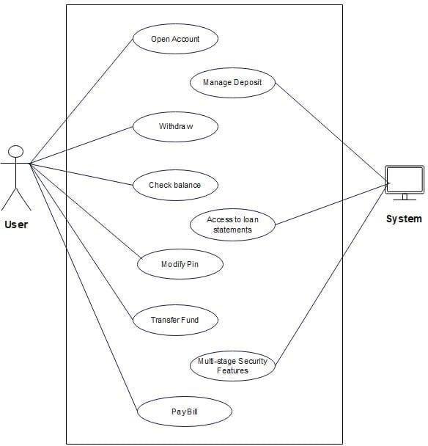

Diagram-1 Use case diagram

### Activity Diagram

Diagram-2 activity diagram

Diagram-3 Activity diagram 2

### Sequence Diagram

Diagram-4 Sequence diagram

Diagram-5 0 level DFD

Diagram-6 1st level DFD

## 2nd level DFD

Diagram-7 DFD

Diagram-8 class diagram

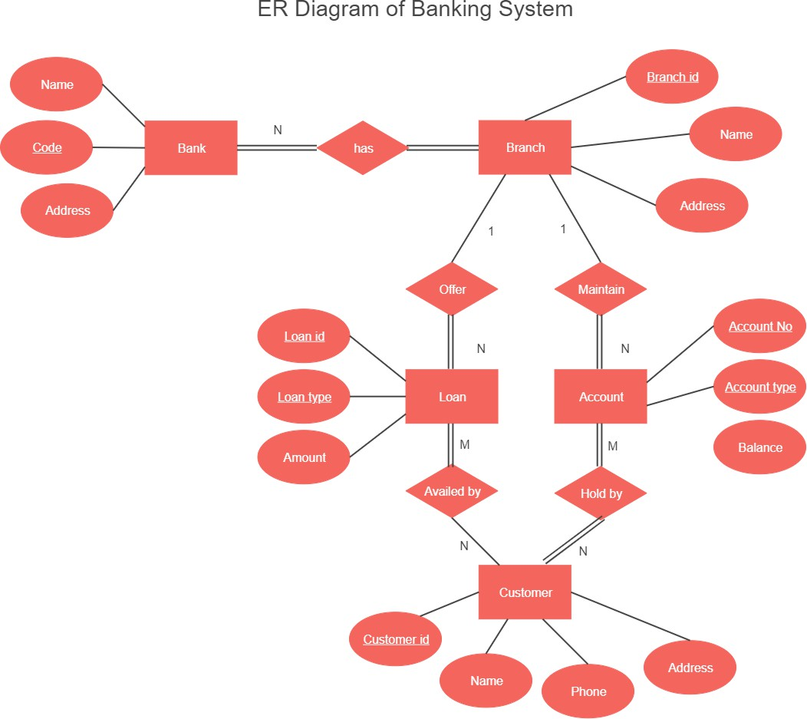

Diagram-9 **E-R Diagram**

**Chapter-4: Implementation**



## Chapter-5: Conclusion

Emphasis on the value of data analysis in improving sports strategies and player evaluation. Future potential of the project to evolve and incorporate more sophisticated analytics. Encouragement to adopt data-driven approaches in sports for better performance and outcomes.

## Chapter-6: Future Scope

* **Advanced Analytics:** Incorporate predictive analytics to forecast player performance.
* **Expanded Metrics:** Include additional performance metrics such as fielding stats, fitness levels, etc.
* **Real-Time Analysis:** Implement real-time data updates for live match analysis.
* **User Customization:** Allow users to customize the dashboard based on specific requirements or preferences.
* **Integration with Other Sports:** Extend the methodology to analyze data from other sports.

## Chapter-7: Bibliography